Exp.No-15
15. Perform Transformation using Direct Linear Transformation (DLT)

Aim:
To perform image transformation using the Direct Linear Transformation (DLT) method in OpenCV.
Procedure:
- Start the program.
- Import the OpenCV and NumPy libraries.
- Read the input image (puppy.jpg).
- Define four source points on the image.
- Define four destination points.
- Calculate the transformation matrix using the DLT method.
- Apply the transformation to the image.
- Display the original and transformed images.
- Save the transformed image.
- Stop the program.
Program:

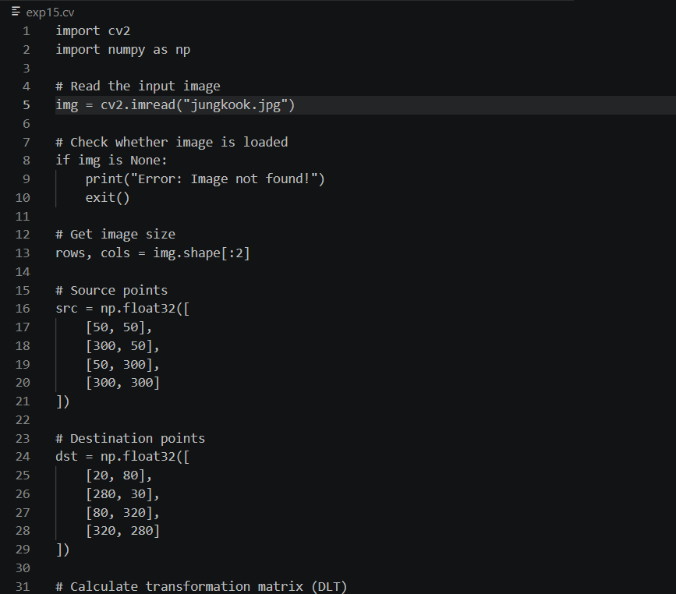
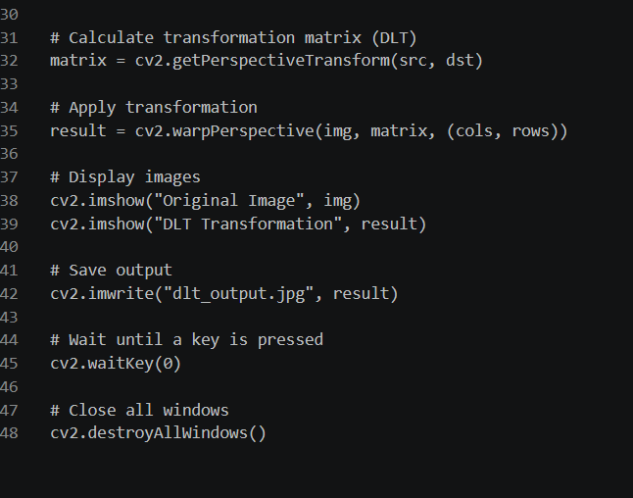

Input:


Output:



Result:
The transformation using the Direct Linear Transformation (DLT) method was successfully performed on the input image. The transformed image was displayed and saved successfully.

